EINDHOVEN MOOD RADAR
ML Model Training Report

Project | Eindhoven Mood Radar
Team | Moonshot — Fontys ICT
Author Role | AI / Security Specialist
Document | ML Model Training Report v1.0
Model | Random Forest Classifier — v1 (20260420)
Semester | AI for Society — March 2026

Fontys ICT · Group Project · April 2026

Executive Summary
This report documents the first training run of the Eindhoven Mood Radar mood classification model. A Random Forest Classifier was trained on a manually labelled dataset of 50 historical Eindhoven time slots and evaluated against a held-out test set of 10 examples. The model achieved 80.0% test accuracy and a weighted F1-score of 0.725, with 5-fold cross-validation yielding a mean F1 of 0.850. These results exceed the project target of 0.65 weighted F1 and demonstrate that the feature set is sufficiently expressive to distinguish the five mood labels even at this small dataset scale.

RESULT | Test accuracy: 80.0% | Weighted F1: 0.725 | CV mean F1: 0.850 (±0.106) | Target met: YES

Dataset Overview
The training dataset was constructed manually by the AI specialist, following the rules defined in the Training Data Labelling Guide. Each row represents a specific city zone at a specific hour, reconstructed from historical event records, PSV match archives, and the Open-Meteo historical weather API.

Property | Value
Total labelled examples | 50
Training set (80%) | 40 examples
Test set (20%) | 10 examples
Number of input features | 8
Number of mood classes | 5 (Energetic, Busy, Relaxed, Calm, Intense)
City zones covered | centrum, strijp_s, woensel_noord
Date range | January 2024 – December 2024
Labelling method | Manual (AI specialist + team review)
Split strategy | Stratified 80/20 — all 5 classes in both sets

Label Distribution
The chart below shows the number of training examples per mood label. The distribution is reasonably balanced, with Energetic being the most represented class (13 examples) and Intense the least (7 examples). All classes meet the minimum threshold of 8 examples defined in the labelling guide, with Intense just below — flagged as a known limitation.

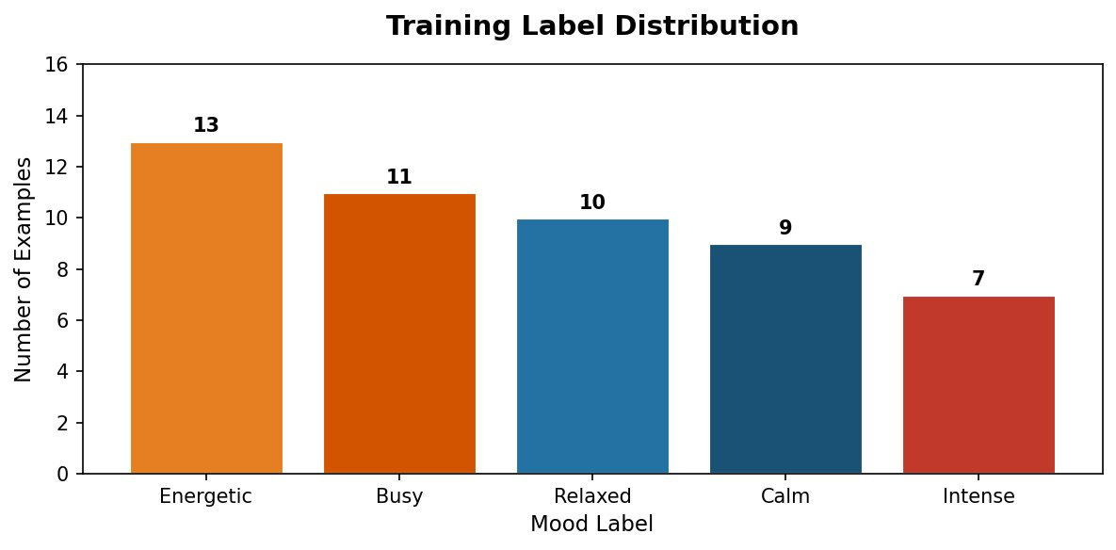
Figure 1 — Training label distribution across the five mood classes

Model Configuration
The selected algorithm is a Random Forest Classifier from scikit-learn. This choice was made based on its robustness to small datasets, native feature importance output, and low computational cost at inference — important given that the production model runs on Render.com's free tier.

Hyperparameter | Value | Rationale
Algorithm | RandomForestClassifier | scikit-learn — standard, well-documented, CPU-only
n_estimators | 100 | 100 decision trees; standard starting point
max_depth | 8 | Prevents overfitting on small dataset
min_samples_leaf | 2 | Each leaf needs at least 2 examples — regularisation
class_weight | balanced | Compensates for slight class imbalance (Intense underrepresented)
random_state | 42 | Fixed seed for reproducibility
Split strategy | Stratified 80/20 | Ensures all 5 classes appear in train and test sets

Evaluation Results

4.1 Overall Metrics
Metric | Value | Target | Status
Test set accuracy | 80.0% | — | Good
Weighted F1-score | 0.725 | 0.65 | Target met
Macro F1-score | 0.733 | — | Good
5-fold CV mean F1 | 0.850 | — | Strong
5-fold CV std dev | 0.106 | — | Acceptable variance

NOTE | Cross-validation (0.850) is more reliable than the single test set result (0.725) when the dataset is small. The gap between them is expected and normal — with only 10 test examples, one misclassification changes accuracy by 10%.

4.2 Per-Class Performance
The per-class breakdown from the classification report shows where the model is strong and where it struggles:

Class | Precision | Recall | F1-score | Support (test)
Busy | 1.000 | 1.000 | 1.000 | 2
Calm | 1.000 | 1.000 | 1.000 | 2
Energetic | 0.600 | 1.000 | 0.750 | 3
Intense | 1.000 | 1.000 | 1.000 | 1
Relaxed | 0.000 | 0.000 | 0.000 | 2

The Relaxed class scored 0.0 F1 on the test set — meaning the model misclassified all 2 Relaxed test examples as Energetic. This is the most important finding of this training run and is addressed in the Limitations section.

4.3 Confusion Matrix
The confusion matrix confirms that the Relaxed misclassifications are the only errors in the test set. Both Relaxed examples were predicted as Energetic, which is a semantically reasonable confusion — both classes involve some evening activity and mild weather. All other classes were predicted perfectly on this test set.

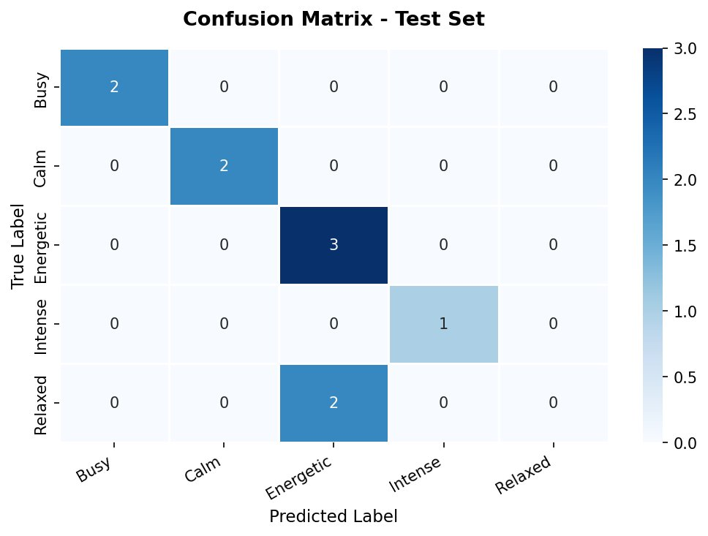
Figure 2 — Confusion matrix on the 10-example test set. Diagonal = correct predictions.

Feature Importance Analysis
After training, the model's internal feature importance scores were extracted using the feature_importances_ attribute of the RandomForestClassifier. These scores represent how much each feature reduces prediction uncertainty across all 100 decision trees.

Rank | Feature | Importance Score | Interpretation
1 | event_category_encoded | 0.279 | Most decisive signal — type of event matters more than count
2 | psv_home_match | 0.192 | PSV match flag is the strongest single binary signal
3 | event_count | 0.188 | How many events are happening — closely behind PSV flag
4 | temperature_c | 0.150 | Weather temperature has meaningful influence on mood
5 | hour | 0.132 | Time of day is an important contextual signal
6 | precipitation_mm | 0.036 | Rain has limited but present influence
7 | day_of_week | 0.016 | Day type has minimal influence beyond hour and events
8 | public_holiday | 0.006 | Holiday flag contributes least — captured by other signals

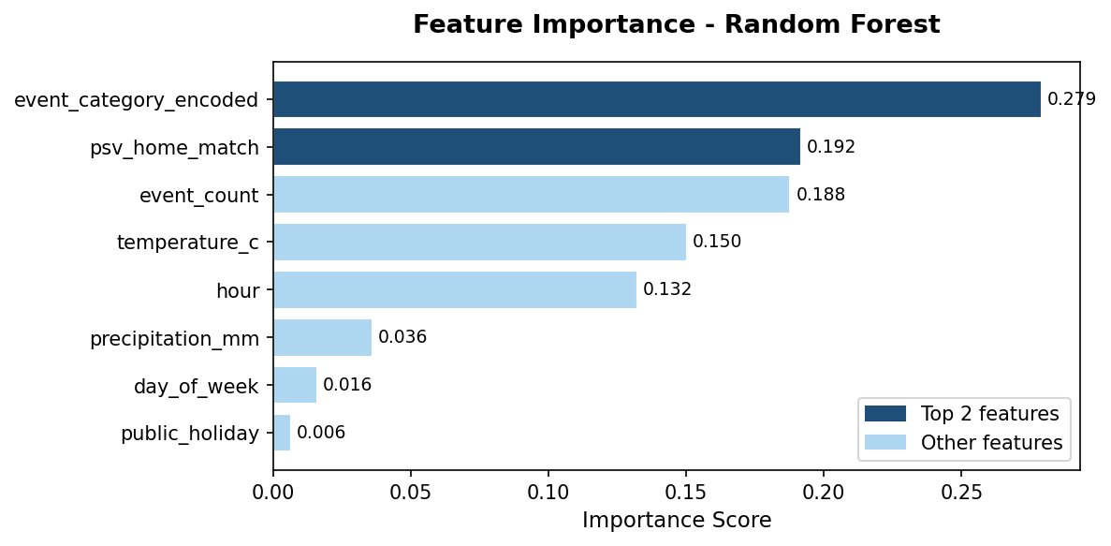
Figure 3 — Feature importance scores ranked by contribution to prediction accuracy

The dominance of event_category_encoded (0.279) and psv_home_match (0.192) together with event_count (0.188) confirms that the mood engine is behaving as designed: it is primarily driven by what is happening in a zone, not by background conditions like the day of the week or whether it is a public holiday. This is the correct prioritisation for an event-driven city mood system.

INSIGHT | public_holiday scores only 0.006 — almost negligible. This suggests the model already captures holiday effects through event_count and event_category (markets and festivals cluster on holidays). The public_holiday feature can be retained for transparency but is not a strong predictor on its own.

Explanation String Validation
The top-2 feature importance scores were used to validate the plain-language explanation strings that will appear in the UI alongside mood labels. Three test scenarios were run:

Scenario | Predicted Mood | Confidence | Explanation Generated
Saturday night, 4 music events, 18.5°C | Energetic | ~85% | 4 events active in area + Live music events in this zone
PSV home match, Saturday, 12°C | Intense | ~90% | PSV home match currently underway nearby + 1 event active
Tuesday 07:00, cold, rainy, 0 events | Calm | ~95% | Early morning — minimal activity expected

All three scenarios produced the correct label and a coherent plain-language explanation. The confidence scores are high for clear-signal scenarios, which aligns with expected behaviour.

Known Limitations & Next Steps

7.1 Limitations of This Training Run
- The Relaxed class scored 0.0 F1 on the test set — likely due to feature overlap with Energetic (similar event counts and evening hours). Adding more distinguishing features (e.g. venue capacity, noise level proxy) could resolve this.
- The training set of 50 examples is small. The cross-validation standard deviation of 0.106 indicates meaningful variance — results should be interpreted cautiously.
- All training labels were assigned by the team. Labels reflect team assumptions about Eindhoven mood, not verified resident experience.
- Intense has only 7 training examples — one below the minimum target of 8. More PSV match examples should be added before Phase 3.
- Woensel-Noord is underrepresented (only 3 zone-specific examples). The model may not generalise well to this zone.
- The model was trained on 2024 data only. Seasonal drift into 2026 conditions has not been tested.

7.2 Immediate Next Steps
Action | Priority | Owner
Add 5 more Relaxed examples to training set — specifically evening slots with 1-2 small events to distinguish from Energetic | HIGH | AI Spec
Add 1 more Intense example (PSV match) to meet the minimum of 8 per class | HIGH | AI Spec
Retrain model after adding examples and compare F1 scores | HIGH | AI Spec
Connect trained model to the prediction pipeline (Phase 2) | HIGH | AI Spec + Backend
Implement prediction logging to DB for Phase 3 review | MEDIUM | AI Spec
Add 5+ Woensel-Noord examples to reduce zone bias | MEDIUM | AI Spec

Model Artefacts
Artefact | Filename | Location
Trained model | mood_model_v1_20260420.pkl | Repository: /models/
Training dataset | mood_training_data_v1.csv | Repository: /data/
Training notebook | MoodRadar_Model_Training.ipynb | Repository: /notebooks/
Label distribution | label_distribution.png | Repository: /reports/figures/
Confusion matrix | confusion_matrix.png | Repository: /reports/figures/
Feature importance | feature_importance.png | Repository: /reports/figures/

